YOUR PROJECT TITLE HERE

Data Set Number, Student Number, Surname, Name
Çankaya University
Faculty of Engineering
Department of Mechanical Engineering
ME307 Machine Elements I, Term Project
FALL 2016

Abstract. (Define the aim of your project shortly.)

Introduction

(Define telescopic boom mini crane, using areas, its main components etc. Give short information about its historical past. Please do not forget to give references.)

Section 1

(You can use as many sections and sub-sections as you need.)

Some hints:
+ You can define your problem clearly in section one.
+ You can define your solution method in section two.
+ You can give the results in section three.

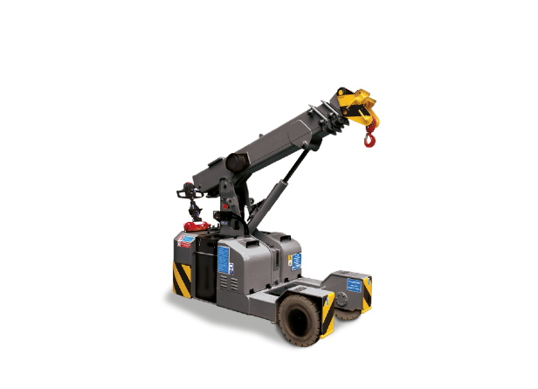
Figure 1. Mini boom crane [1]

Table 1. Data Sets
Materials of the links | 1040 | 1030 | 1040 | 1030
Material of pins | 1060 | 1060 | 1060 | 1060
Material of the shaft | 1080 | 1095 | 1080 | 1095
Material of the key | 1035 | 1010 | 1010 | 1035

$σ=\frac{F}{A}$ (1)

+ Please obey the font type and font size (Times New Roman – 12pt).
+ For all equations you used please write down with using Word equation editor.
+Please draw all free body diagrams with using software (Word, Photoshop etc.).
+ Please draw all diagrams with using software (Excel, MATLAB, Mathematica etc.).
+ Please give the technical drawings using CAD tools (AutoCAD, Inventor etc.). For more information, please read the project papers.
+ Please give references for all information, tables and figures you take from outsources.
Conclusion
(Here, summarize your project.)
References
[1] http://hird.co.uk/products/valla-pick-carry-cranes/25el/ (Last Access: 1.12.2016, 11:16)
[2] Chin, C., Nayfeh, A. H., and Abdel-Rahman, E. "Nonlinear dynamics of a boom crane." Journal of Vibration and Control 7(2) (2001): 199-220.

